**Lecture 28**

**Design of screw conveyor**

The screw conveyor consists of a tubular or U-shaped trough in which a shaft with spiral screw revolves. The screw shaft is supported by end and hanger bearing. The rotation of screw pushes the grain along the trough. The screw conveyor is used in grain handling facilities, animal feed industries and other installations for conveying of products generally for short distances. Screw conveyor requires relatively high power and is more susceptible to wear than other types of conveyors. The pitch of a standard screw which is the distance from the centre of one thread to the centre of the next thread, is equal to its diameter.

The screw conveyor’s driving mechanism is simpler and no tensioning device is required therefore, the initial cost of the conveyor is lower than any other conveyor with the same length and capacity. The main parts of a screw conveyor are, screw blade, screw shaft, trough, inlet and outlet gates, bearings and drive mechanism.

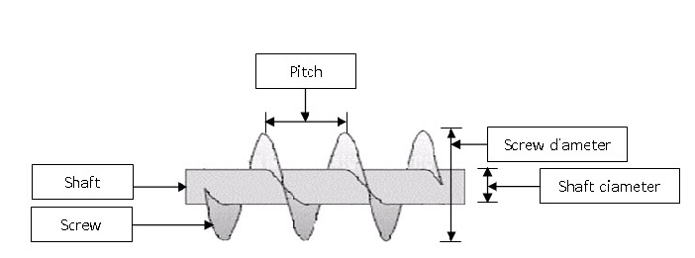

**Figure 1 Screw conveyor details 1. Screw diameter 2. Pitch of screw 3. Screw length**

The screw conveyor is generally used to move grains horizontally. However, it can also be used at any angle upto 90° from the horizontal, but the capacity correspondingly reduced as per the inclination of conveyance.

The screw basically consists of a shaft and the screw blade or flight. The flight is a continuous one piece helix, shaped from a flat strip of steel welded onto the shaft.The screw shaft is usually a jointless tube with thick sides and a high tensile strength to reduce the weight. The thickness of the steel strip helix decreases from the inner edge to the outer edge.

Troughs of screw conveyor have different shapes. Most common is U-shaped trough. In an enlarged or flared trough the side walls become wider at the top. This type of trough is usually used for conveying non-easy flowing materials which may have lumps. The tubular trough is completely closed with circular x-section and mostly used for conveying materials at inclination or for vertical lift.

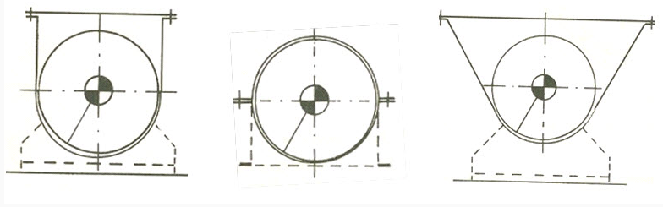

**Figure 2 various shapes of screw conveyor trough**

For operational reasons, some gap is provided between the edge of the screw blade and the trough walls. Due to this gap, it is not possible to completely empty the trough of a horizontal screw conveyor. If the screw conveyor is used to convey different materials, mixing of products is possible. Also, when the kernels are pressed between the screw edge and trough walls, they can be damaged. During conveyance, the kernels are also subjected to continuous friction with the trough walls. Screw conveyor may be designed for clockwise or counter-clockwise rotation. The change in direction of rotation does not affect the capacity.

The capacity of screw conveyor is influenced by the screw diameter, inclination of the screw blade, speed of the blade, shaft diameter and cross-section of loading. The theoretical conveyance capacity of the screw conveyor can be calculated by the following equation.

Capacity



Where,

D = screw diameter, m

d = shaft diameter, m

p = pitch, m

n = rpm

The power requirement of screw conveyors for horizontal operation may be determined by the following equation.

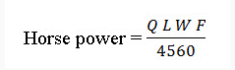

Where,

Q = conveyor capacity, m3/min

L = conveyor length, m

W = bulk material weight, kg/m3

F = material factor

Screw conveyors can be operated in an inclined position. In this case, the material will be conveyed upward. The capacity of inclined screw conveyor decreases than the horizontal operation. A screw conveyor inclined 15 degree will carry about 75% of the rated horizontal capacity. At an inclination of 25 degrees, it will carry about 50 % of the rated horizontal capacity.

Loading and discharge of a screw conveyor can be take place at several places. The loading of a horizontal or inclined screw conveyor is generally accomplished through a supply chute connected at the flat trough cover. A special feeding device is provided for loading of material in a vertical and tubular screw conveyor.

The product supply should be regular to avoid overfilling and congestion in a screw conveyor. To regularize product flow an adjustable opening at the feeding point should be provided. The product can be discharged either at the end of the screw or the intermediate discharge can be achieved through an opening in the bottom of the trough.

**Lecture 29**

**Design aspects of bucket elevator, construction and operation**

Material handling includes number of operation that can executed either by hand or mechanical means or devices to convey the material and to reduce the human drudgery. A mechanical handling device aims to lighten the work of human labors. After harvesting the grains are moved, transported or conveyed from one place to another.

A bucket elevator consists of buckets attached to a chain or belt that revolves around two pulleys one at top and the other at bottom. The bucket elevator is a very efficient deivce for the vertical conveyance of bulk grains. The elevator can lift the materials between few meters to more than 50 m. Capacities of bucket elevators may vary from 2 to 1000 t/h. Bucket elevators are broadly classified into two general types;

1) Spaced bucket elevators

2) Continuous bucket elevator

The above two types are further sub divided into various classed.

The spaced bucket elevators are further classified as;

a) Centrifugal discharge elevators

b) Positive-discharge elevators

c) Marine leg elevators and

d) High-speed elevators.

The continuous bucket elevators are classified as;

a) Super capacity bucket elevators and

b) internal-discharge bucket elevators.

The spaced-bucket centrifugal discharge type is most commonly used for elevating the grains. Bucket elevators with belts are used in food industries for vertical conveyance of grains, its derivatives and flours. Bucket elevators have high capacities and it is a fairly cheap means of vertical conveyance. It requires limited horizontal space and the operation space and the operation of conveying is enclosed in housing, thus it is dust free and fairly quiet.

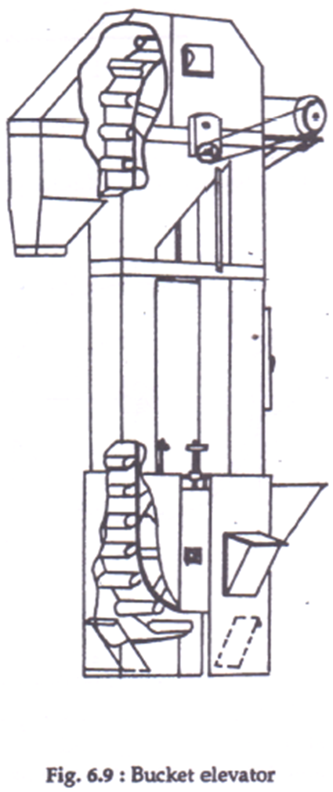

**Figure 1 Bucket Elevator**

In a bucket elevator, the conveyor belt with buckets runs over pulleys at the upper and lower ends. The top pulley is driven pulley while the lower pulley is return and tension pulley. Buckets are usually made of steel or plastic and are bolted onto the belt. The buckets may be enclosed in a single housing called leg or two legs. The return leg may be located at some distance from the elevator leg. The housing or legs are also made of steel are welded or bolted together and are dust tight. The curved hood is designed for proper centrifugal discharge of the grains. The boot can be loaded from the front or back or both. The product flow is discharged either by means of gravity or centrifugal force.

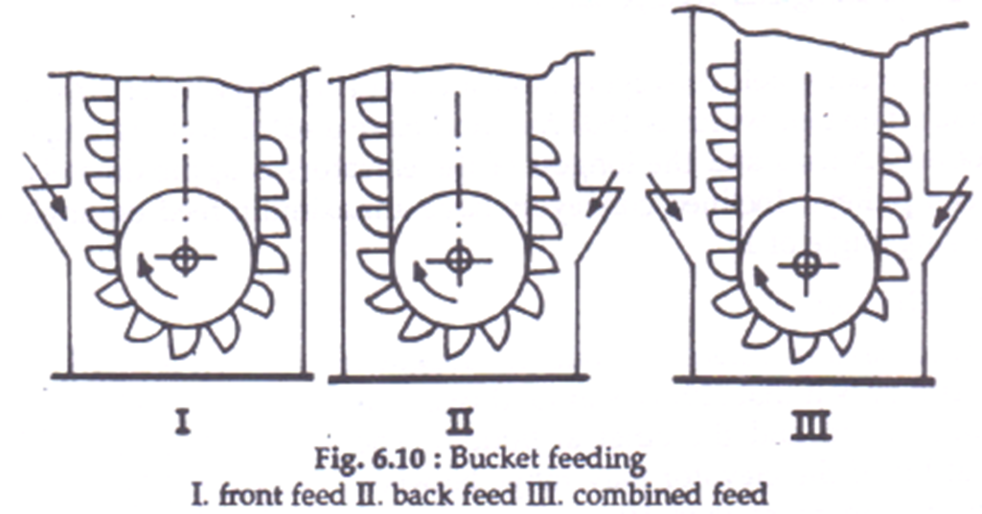

**Figure 2 Bucket Feeding I. Front Feed II. Back Feed III. Combined feed**

The bucket elevator’s capacity mainly depends on bucket size, conveying speed, bucket design and spacing, the way of loading and unloading, the bucket and the characteristic of bulk material. Bucket elevators with a belt carrier can be used at fairly high speeds of 2.5 to 4 m/s. The speed of the belt depends upon the head pulley speed. A properly designed bucket elevator driven at the correct speed will make a clean discharge. If the belt speed is too low, the discharge of the grains becomes more difficult, with too high speed the buckets are not fed well.

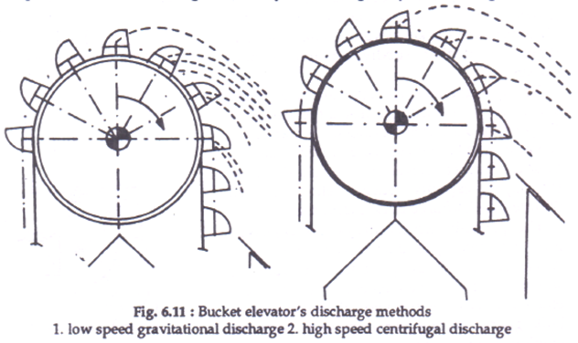

**Figure 3 Bucket Elevators discharge methods 1. Low speed gravitational discharge 2. High speed centrifugal discharge**

In elevating of grains the discharge from bucket elevators is a combination of centrifugal and gravitational discharge. Part of the bucket contents is projected by the centrifugal force; the rest flows out by gravity.

The bucket elevator’s capacity can be calculated by the following equation.

t/hr

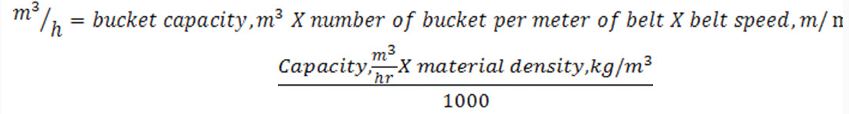

The main parts of a bucket elevator are;

- elevator head and boot section

- elevator legs

- belts for bucket elevator and

- buckets.

*Head and Boot Section*

The head section should be of the proper shape and size with smooth counters. The discharge side of the head should be shaped so that material thrown from the buckets may not deflect into the down leg. When the product is not thrown well clear of the buckets into the discharge chute, it will fall in the down leg. This is called as “back logging”. The back logged material has to be re-elevated, thus it reduces the capacity of the elevator. To avoid back-logging, an adjustable cut off plate is provided close to the lip of bucket.

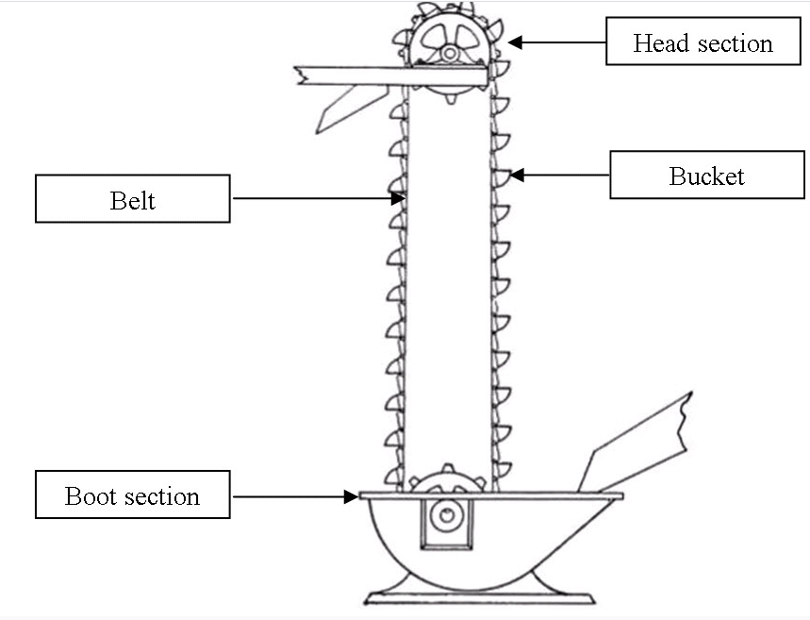

**Figure 4 Head and Boot Section**

Bucket elevators boots should be of bolted assembly to allow for proper maintenance and replacement of pulley, shaft and other accessories. In the boot section, the loading chute should be located at such point that the pick-up of the product by the buckets takes place above the centre line of the return pulley.

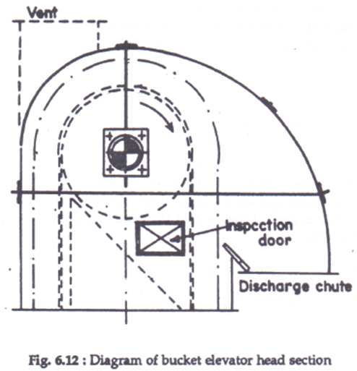

**Figure 5 Diagram of bucket elevator head section**

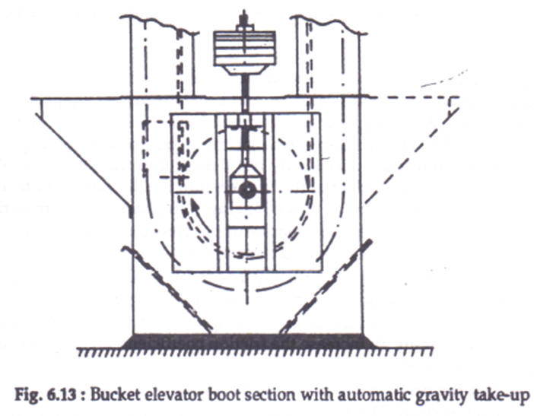

**Figure 6 Bucket elevator boot section with automatic gravity take up**

**Elevator legs**

The up and down moving string of buckets in bucket elevators are enclosed in elevator legs. The elevator legs stop the emission of dust. These legs are constructed as all welded, bolted or riveted. The strings of up and down moving buckets can either run in a common leg or in separate legs. With double legs, a balanced pressure can be obtained by ducts connecting on different levels of the up going and down going trunk. Service and inspection openings are needed as it requires adequate maintenance.

**Elevator Belts**

In a normal operation of the bucket elevator, the loads exerted by the elevator height, product weight, weight of bucket belt and idle tension and the digging resistance are taken by the belt. The bucket elevator belt has no support between the drive and the return pulleys, therefore, cross stiffness of belt is very important. Most conveyor belts consist of synthetic fibres like polyesters and polyamide and built up with synthetic rubber or PVC. To increase tensile strength of belt, several layers of fibres are put together to build a carcass. Such carcass is able to withstand very high tensile forces with minimum of stretch.

During continuous operation, elevator belts are susceptible to various mechanical stresse3s which may cause wear. The friction between drive pulley and the belt causes wear in the underside of the belt. The back falling product is caught and crushed between the belt and return pulley. Extra forces are also exerted on the belt by rigid buckets while passing over the head pulley.

**Buckets**

As per the requirements, buckets are made of different materials and come in various shapes and sized. The shape of the bucket is very important for filling and discharge. Digging in of buckets in the elevator boot and the centrifugal discharge at the elevator head influence the shape of buckets.

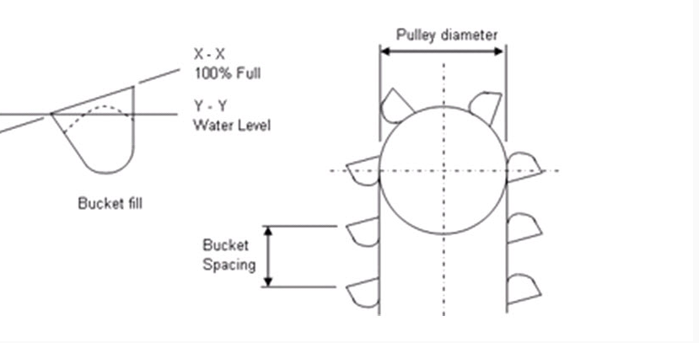

**Figure 7 Bucket Design**

For centrifugal discharge the resultant of product weight and the centrifugal force should preferably be directed towards the lip of the bucket. The buckets should have a wide open mouth for digging and discharging the product. The conveying capacity of the elevator also depends upon the number of buckets per metre belt length.

The capacity and discharge of each bucket is influenced by the previous bucket, hence the distance between two successive buckets is important. Therefore, compromise between the following factors is required 1) the design and content of the buckets, 2) the shortest distance between successive buckets without any mutual influence, 3) for centrifugal discharge the appropriate belt speed and diameter of drive pulley. In general, the spacing would be from 2.0 to 3.0 times the projected width of bucket.

**Drive mechanism**

The drive mechanism of a bucket elevator is located near the elevator head. At the elevator head, the belt is turned around the drive pulley. Drive motor with gear box and couplings are mounted on a rigid and separate frame. For serving the elevator head section, the drive mechanism, a working platform is provided. Usually a ladder is provided for access to this platform.

The theoretical horsepower requirement for the bucket elevator can be calculated by the following equation

Hp = QHF

4562

Where,

Q = capacity of bucket elevator, kg/min

H = lift of elevator, m

F = factor 1.5 for elevators loaded on the up side and 1.2 for elevators loaded on the

bottom side

The theoretical horsepower should be increased 10-15% to provide for friction and power requirements for loading, power transmission and drive losses.

**Lecture 30**

**Design of a pneumatic conveyor, Construction and operation**

The pneumatic conveyor moves granular materials in a closed duct by a high velocity air stream. Pneumatic conveying is a continuous and flexible transportation method. The material is carried in pipelines either by suction or blowing pressure stream.The granular materials because of high air pressure are conveyed in dispersed condition. For dispersion of bulk material, air velocities in the range of 15 – 30 m/s is necessary.

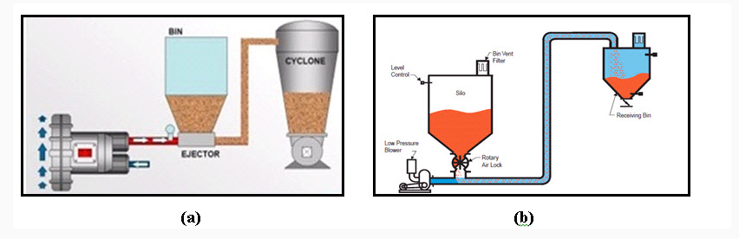

**Figure 1. Pneumatic conveying system**

The pneumatic conveying system needs a source of air blowing or suction, means of feeding the product into the conveyor, ducts and a cyclone or receiving hopper for collection of product. There are three basic systems of pneumatic conveying. These are pressure or blowing system, suction or vacuum system and combined push-pull or suck blow system.

In blowing or positive pressure systems, the product is conveyed by using air pressures greater than the atmospheric pressure. The selection of air mover is the most important aspect of the design of a pneumatic conveying system. Two factors, supply air pressure and the volumetric flow rate of air should be considered in designing.

For separation of product particles from air, air-product separators are used. Cyclones are mostly used to collect the particles. Cyclone is a device which removes the bulk of the product particle from the conveying air stream by centrifugal force. In some cyclone, a fabric filter is attached to remove residual dust and fine product particles from the air stream.

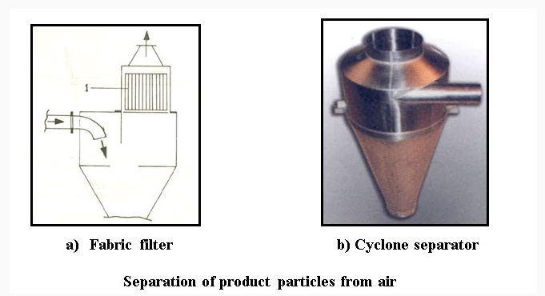

**Figure 2. Separation of product particles from air**

The volumetric flow rate of air depends on the necessary air velocity and pipe or duct size used in the system. In pneumatic conveying systems, fans and blowers with high volumetric flow rates and lower pressures to positive displacement compressors producing high pressures are used.

**Modes of conveying**

If the material is conveyed in suspension in the airthrough the pipeline it is referred to as **dilute phase** conveying. If the material is conveyed at low velocity in a non-suspension mode, through all or part of the pipeline, it is referred to as **dense phase** conveying.

**Air velocity conveying**

For dilute phase conveying a relatively high conveying air velocity must be maintained. This is typically in the region of 12 m/s for a fine powder, to 16 m/s for a fine granular material, and beyond for larger particles and higher density materials. For dense phase conveying, air velocities can be down to 3 m/s, and lower in certain circumstances. This applies to both moving bed and plug type dense phase flows.These values of air velocity are all conveying line inlet air velocity values. Air is compressible and so as the material is conveyed along the length of a pipeline the pressure will decrease and the volumetric flow rate will increase.

For air the situation can be modelled by the basic thermodynamic equation:



where p is the air pressure (kN/m2 abs), V the air flow rate (m3/s), T, the air temperature (K) and subscripts 1 and 2 relate to different points along the pipeline.

If the temperature can be considered to be constant along the length of the pipeline this reduces to:



Thus if the pressure is one bar gauge at the material feed point in a positive pressure conveying system, with discharge to atmospheric pressure, there will be a doublingof the air ﬂow rate, and hence velocity in a single bore pipeline. If the conveying line inlet air velocity was 20 m/s at the start of the pipeline it would be approximately40 m/s at the outlet. The velocity, therefore, in any single bore pipeline will always be a minimum at the material feed point.

**Particle velocity**

In dilute phase conveying, with particles in suspension in the air, the mechanism of conveying is one of drag force. The velocity of the particles, therefore, will be lower than that of the conveying air. It is a difficult and complex process to measure particle velocity, and apart from research purposes, particle velocity is rarely measured. Once again it is generally only the velocity of the air that is ever referred to in pneumatic conveying.

In a horizontal pipeline the velocity of the particles will typically be about 80% of that of the air. This is usually expressed in terms of a slip ratio, defined in terms of the velocity of the particles divided by the velocity of the air transporting the particles, and in this case it would be 0.8. The value depends upon the particle size, shape and density, and so the value can vary over an extremely wide range. In vertically upward flow in a pipeline a typical value of the slip ratio will be about 0.7

**Solids loading ratio**

Solids loading ratio, or phase density is a useful parameter in helping to visualize the flow. It is the ratio of the mass flow rate of the material conveyed divided by the massflow rate of the air used to convey the material. It is expressed in a dimensionless form:

Where ɸ is the solids loading ratio, mp the mass flow rate of material (tonne/h) and ma mass flow rate of air (kg/s).

**Pipeline feeding devices**

A review is given of all the commercially available devices that are used for feeding materials into pneumatic conveying system pipelines, and that meet the requirements of all the different types of conveying system considered in the previous chapter. This includes:

* Rotary valves and the many derivatives
* Screw feeders and the various types available
* Venturi feeders
* Gate lock valve feeders
* Blow tank devices and the multitude of arrangements and conﬁgurations
* Vacuum and suction nozzles
* Trickle valves

**Positive pressure pneumatic conveying system**

Positive pressure conveying systems discharging to a reception point atatmospheric pressure are probably the most common of all pneumatic conveying systems, the feeding of a material into a pipeline in which there is air at pressure does present a number of problems.

A wide range of material feeding devices, however are available that can be used with this type of system, from verturis and rotary valves to screws and blow tanks.

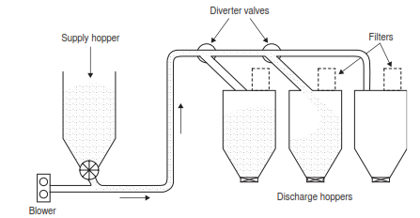

**Figure 3 Positive pressure conveying system**

**Negative pressure (vacuum) systems**

Negative pressure systems are commonly used for drawing materials from multiple sources to a single point. There is little or no pressure difference across the feeding device and so multiple point feeding into a common line presents few problems. As a consequence, the feeding device can be a very much cheaper and simpler item in a negative pressure system than in a positive pressure system. A sketch of a typical system is given in Figure. It will be seen from Figure that the receiving hopper and ﬁltration unit both have to operate under vacuum in this system. As a consequence of this there are three further basic differences between the negative and positive pressure conveying systems to be considered:

1. The receiving vessel has to be designed to withstand the appropriate vacuum.

2. The ﬁltration plant has to be larger, as a higher volume of air has to be ﬁltered under vacuum conditions.

3. In continuously operating systems material will need to be withdrawn from the reception vessel, but with it operating under vacuum air may leak across the discharge valve.

This is effectively a ‘mirror image’ of the problem of feeding material against an adverse pressure gradient reported above for the positive pressure system. Negative pressure systems are also widely used for drawing materials from open storage and stockpiles, where the top surface of the material is accessible. This is achieved by means of suction nozzles. Vacuum systems, therefore, can be used most effectively for off-loading ships. They are also particularly useful for cleaning processes, such as the removal of material spillages and dust accumulations.

**Air leakage**

In vacuum systems the material feeding is invariably at atmospheric pressure and so the pipeline can either be fed directly from a supply hopper or by means of suction.

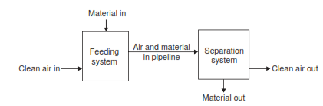

**Figure 4 Air Flow system**

The nozzles from a storage vessel or stockpile. The main point to bear in mind, however, is that there will be no adverse pressure gradient against which the material has to be fed.The feeder, therefore, does not have to be designed to additionally withstand a pressure difference. With no adverse pressure drop to feed across it also means that there will be no leakage of air across the device when feeding material into the pipeline.

Separation systems in these cases, therefore, by necessity, do have to operate under vacuum conditions. In positive pressure systems, separation devices invariably operate at atmospheric pressure. Pipeline feeding in positive pressure systems represents a particular problem, however, for if the material is contained in a storage hopper at atmospheric pressure,the material has to be fed against a pressure gradient. As a consequence of this there may be a loss of conveying air. The feeding device in this case has to be designed to withstand the pressure difference in addition.

In certain cases this air ﬂow can hinder the downward gravity ﬂow of material into the feeder and hence interfere with the feeding process. Also, if the loss is signiﬁcant, the volumetric air ﬂow rate will have to be increased to compensate, for the correct air ﬂow rate to the pipeline must be maintained for conveying the material. This loss, therefore, represents a loss of energy from the system.

**Rotary valves**

The rotary valve is probably the most commonly used device for feeding material into pipelines. This type of feeder consists of a bladed rotor working in a ﬁxed housing. In many applications in which it is used its primary function is as an airlock, and so is often referred to as a rotary air lock. This basic type of valve is generally suitable for free ﬂowing materials.

**Valve wear**

By the nature of the feeding mechanism, rotary valves are more suited to relatively non-abrasive materials. This is particularly the case where they are used to feed materials into positive pressure conveying systems. By virtue of the pressure difference across the valve, and the need to maintain a rotor tip clearance, air will leak across the valve. Wear, therefore, will not only occur by conventional abrasive mechanisms, but by erosive wear also. The problem of erosive wear can be a particularly serious one in pneumatic conveying.

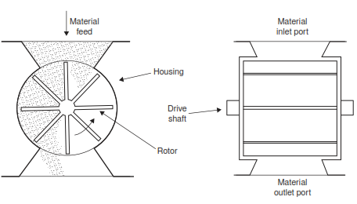

**Figure 5 Drop through rotary valve**

Air leakage through the blade tip clearances, as a consequence of the pressure difference, can generate high velocity ﬂows.This high velocity air ﬂow will entrain ﬁne particles, and the resulting erosive wear can be far more serious than the abrasive wear. Wear resistant materials can be used in the construction of rotary valves, and removable lining plates can be incorporated to help with maintenance, but wear can only be minimized,it cannot be eliminated if an abrasive material is to be handled.

For vacuum conveying duties there is no pressure drop across the valve when feeding, and so with no air leakage there is no erosive wear, only abrasive wear. This is only the situation when a rotary valve is used to feed a pipeline for a vacuum conveying system. If a rotary valve is used to off-load material from a hopper in a vacuum conveying system the situation is effectively the same as described above for feeding a positive pressure system. In this case the leakage air will additionally by-pass the conveying system by being drawn directly into the exhauster, and so starve the conveying pipeline of air.

By the same reasoning there will be no air leakage, and hence no erosive wear, with a rotary valve when used for off-loading material from a reception hopper on a positive pressure conveying system.

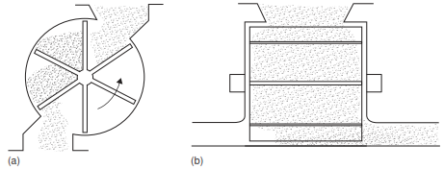

**Figure 6 Rotary valve – a. offset valve b. blow through valve**